**Task 1: Project Design and Structure**

Use–Case-Diagram

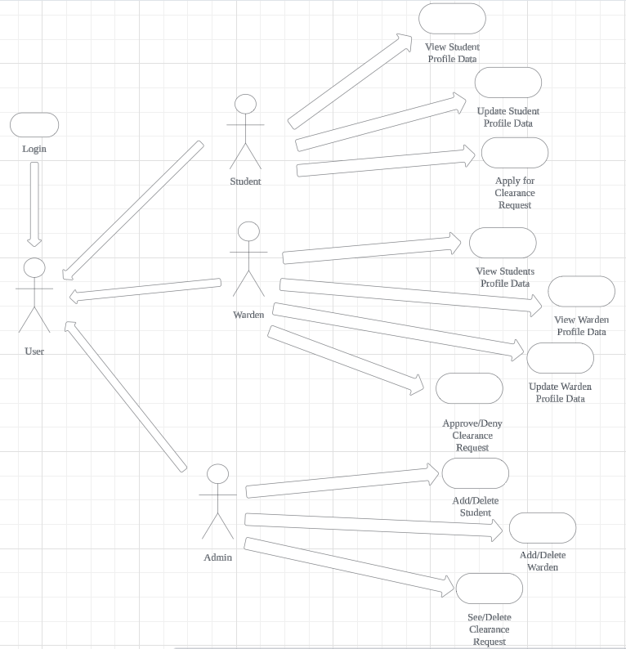

Add/Delete Room

Sequence Diagram for Applying for Clearance Request use case – actor: Student

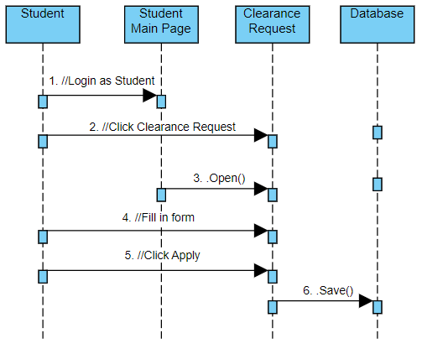

Sequence Diagram for See/Update Student Profile Data use case – actor: Student

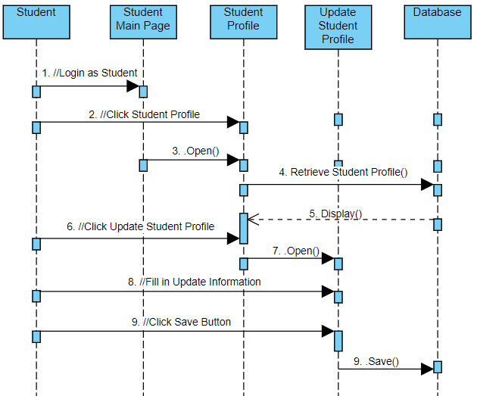

Sequence Diagram for Approving/Denying Clearance Request use case – actor: Warden

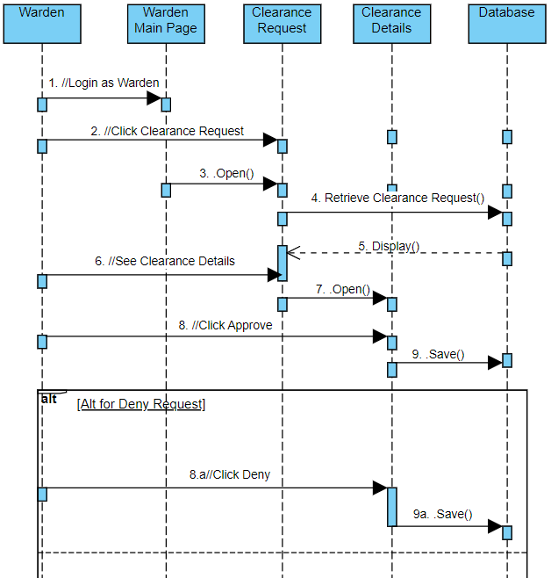

Sequence Diagram for See/Update Warden Profile Data use case – actor: Warden

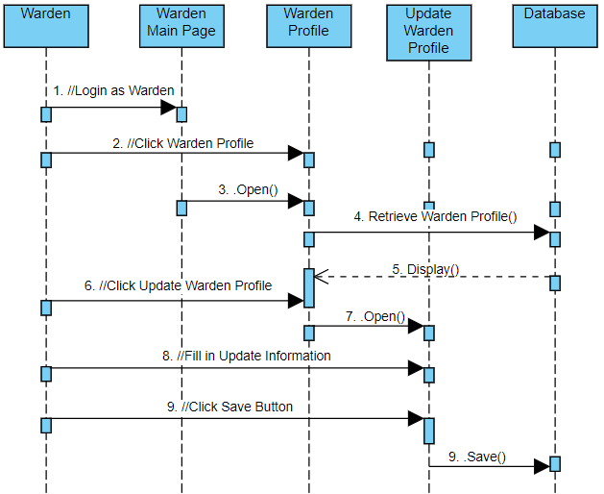

Sequence Diagram for Add/Delete Student Data use case – actor: Admin

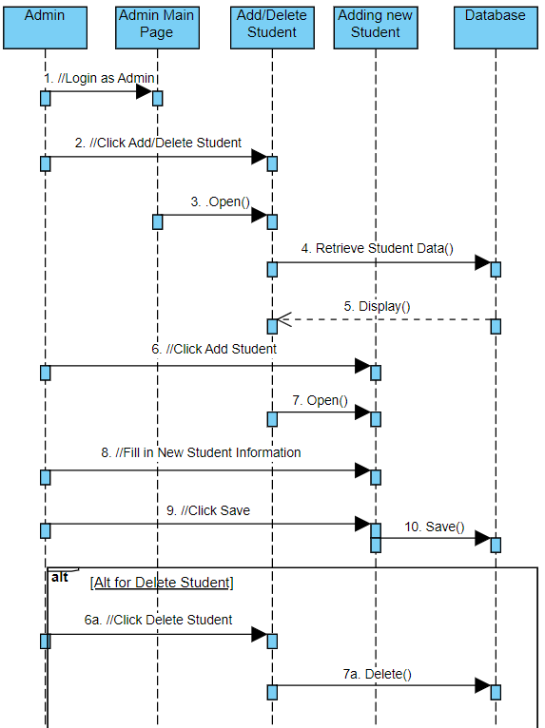

Sequence Diagram for Add/Delete Warden Data use case – actor: Admin

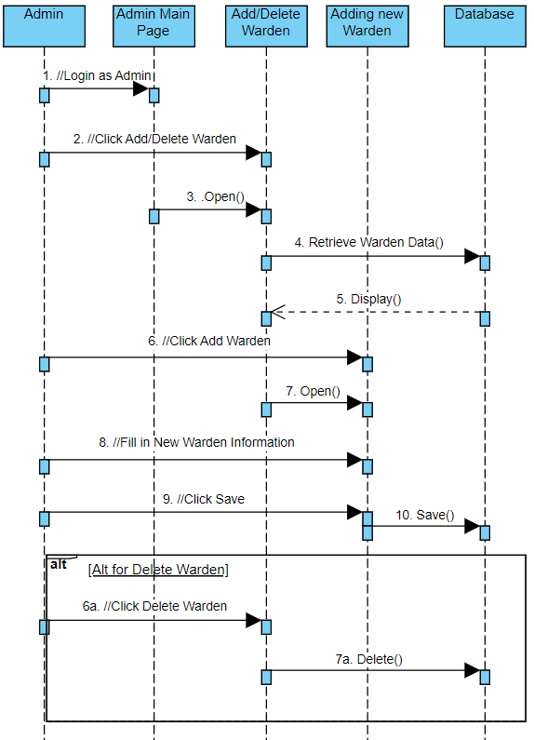

Sequence Diagram for Add/Delete Room Data use case – actor: Admin

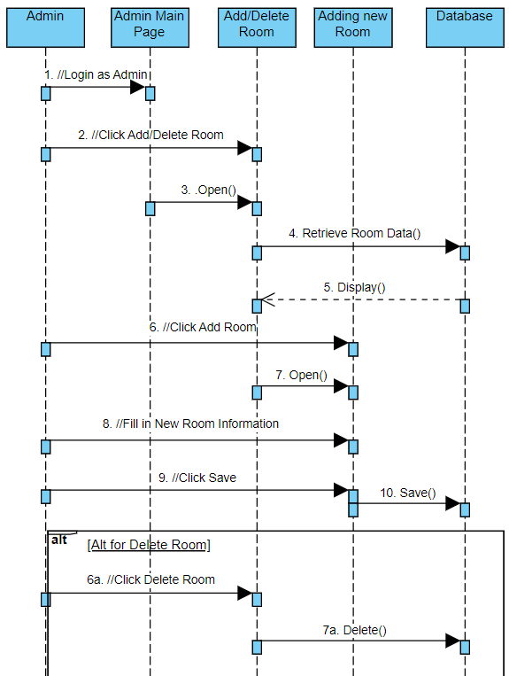

Sequence Diagram for See/Delete Clearance Request use case – actor: Admin

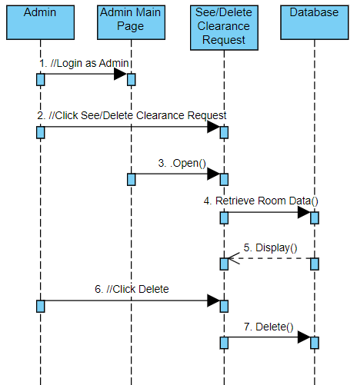

Class Diagram for Student Clearance System

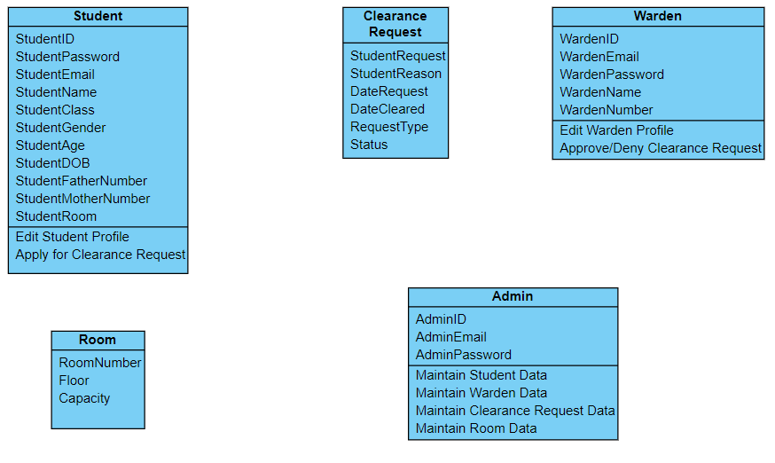

Room Associated With

See Student Data

Approve/Deny Clearance Request

Apply for Clearance Request

Maintain Warden Data

Maintain Clearance Request Data

Maintain Student Data

Maintain Room Data

Storyboard  
  
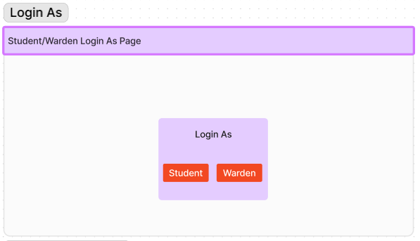

This is the main page for user who just open the page. There are two button they can click on, Student and Warden depending on their role

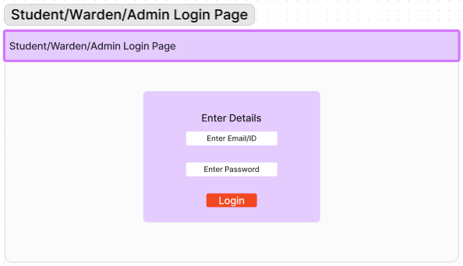

This is the login page after user choose which role they pick. The user will have to input their email and password based on the data that have been save in the database.

Student Storyboard

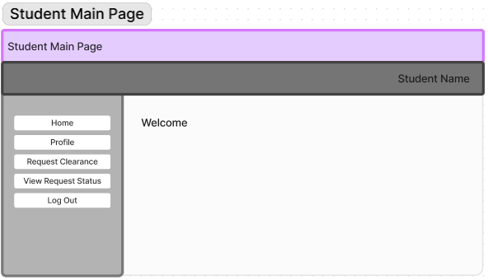

This is the student main page after the user login as a student or click Home. There are five button that will link them to other site such as Home, Profile, Request Clearance, View Request Status and Log Out

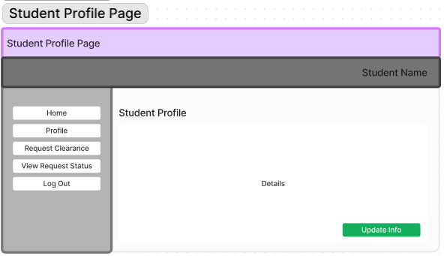

This is the student profile page when the user press Profile. User can see their profile details and also update info of their profile by pressing Update Info button

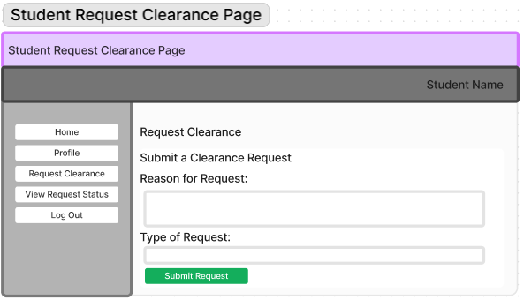

This is the student clearance request page when the user press Request Clearance. User can fill in a form as to what their request for and what type of request. After that they can press Submit Request where it will save the request in the database.

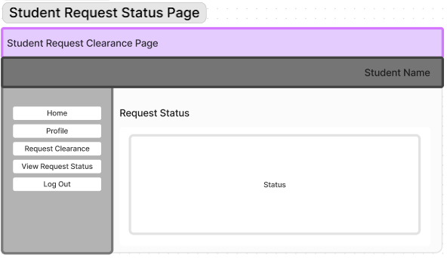

This is the student request status page when the user press View Request Status. User can see the status of their request whether it has been approved or not.

Warden Storyboard

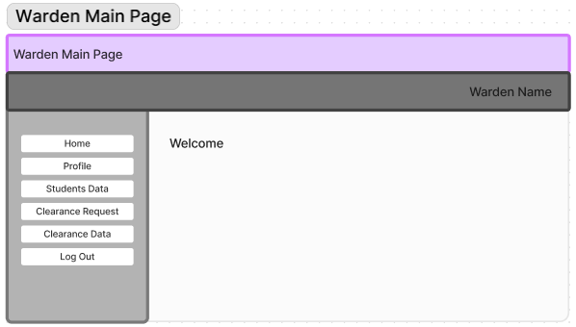

This is the warden main page after the user login as a Warden or click Home. There are six button that will link them to other site such as Home, Profile, Students Data, Clearance Request Clearance Data and Log Out.

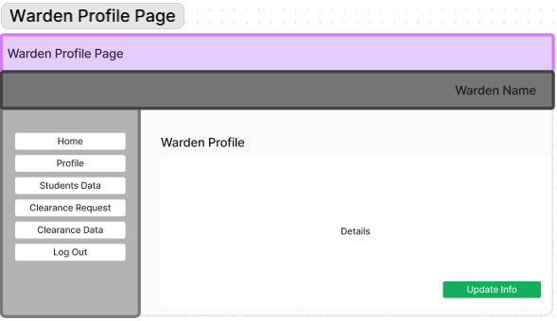

This is the warden profile page when the user press Profile. User can see their profile details and also update info of their profile by pressing Update Info button.

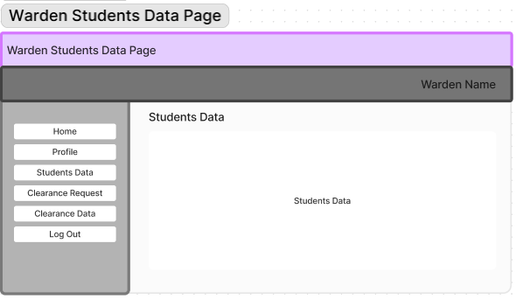

This is the warden student data page when the user press Students Data. User can read all the details and data of other students in this page.

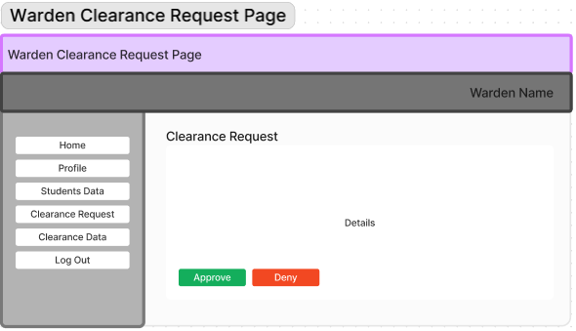

This is the warden clearance request page when the user press Clearance Request. User can read the clearance request available and approve or deny the request posted.

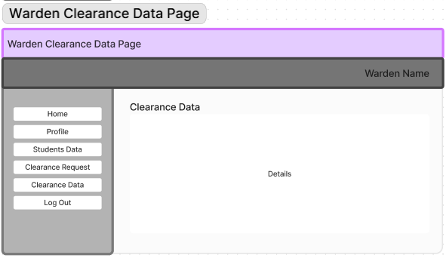

This is the warden clearance data page when the user press Clearance Data. User can read the past clearance data they have approve or deny before.

Admin Storyboard

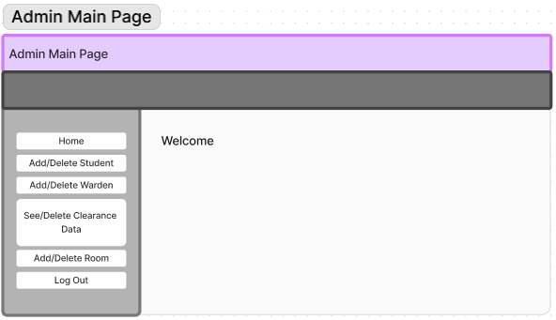

This is the admin main page after the user login as an admin or click Home. There are six button that will link them to other site such as Home, Add/Delete Student, Add/Delete Warden, See/Delete Clearance Data, Add/Delete Room and Log Out.

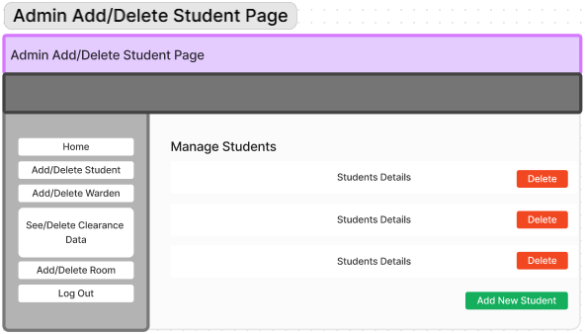

This is the admin Add/Delete Student page after the user press Add/Delete Student. User can choose to either delete the existing student details or add new student where they will fill a form to create new student data.

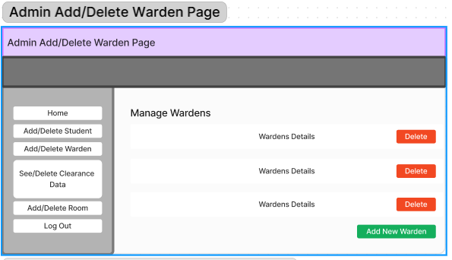

This is the admin Add/Delete Warden page after the user press Add/Delete Warden. User can choose to either delete the existing warden details or add new warden where they will fill a form to create new warden data.

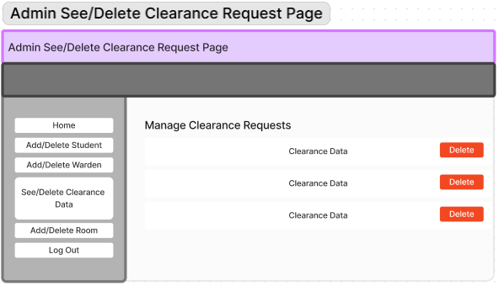

This is the admin See/Delete Clearance Request page after the user press See/Delete Clearance Request. User can see all the past and current clearance request and can choose to delete the request.

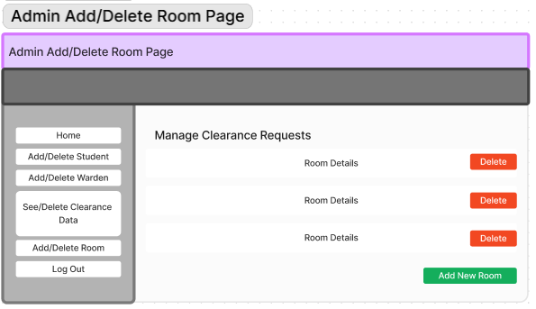

This is the admin Add/Delete Room page after the user press Add/Delete Room. User can choose to either delete the room or add a new room where they will have to fill in a form to create a new room.

**Task 2: Project Implementation**

Main Page

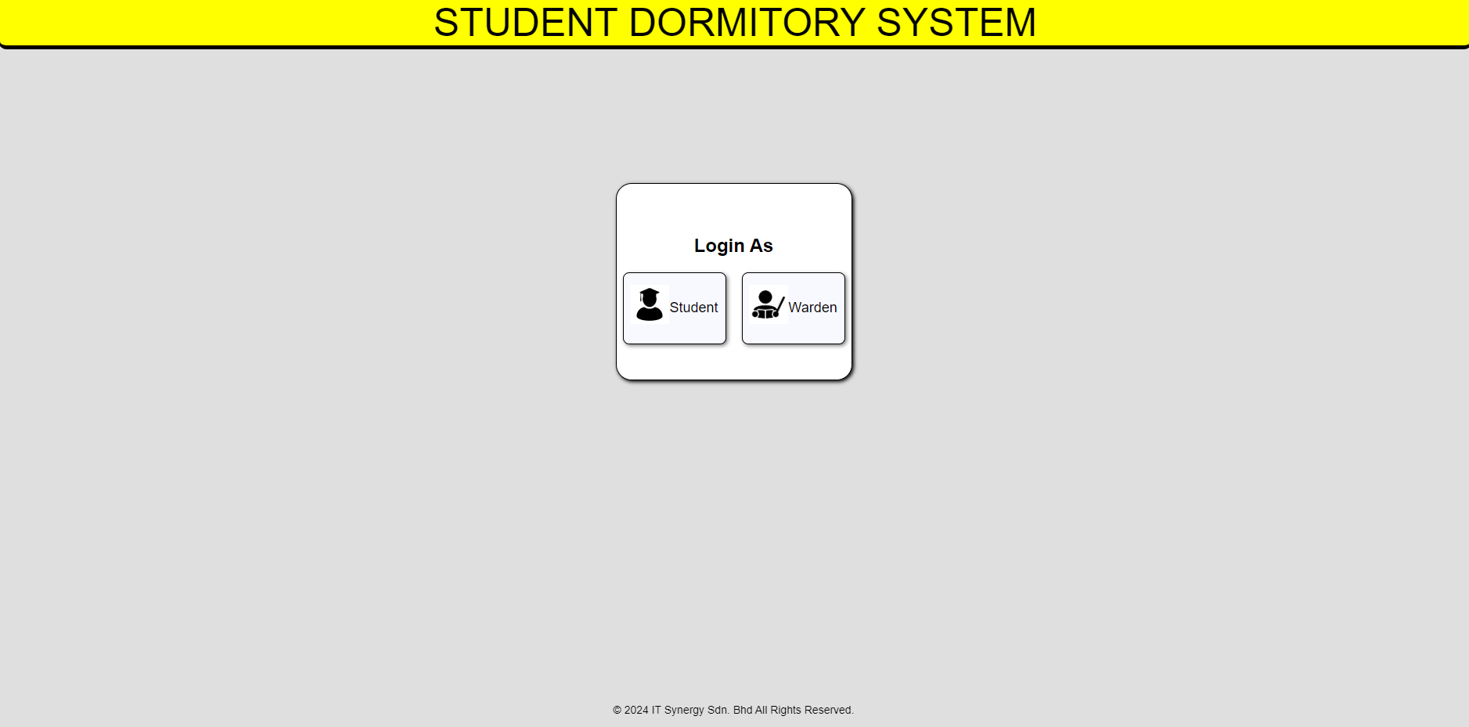

Login Page Student

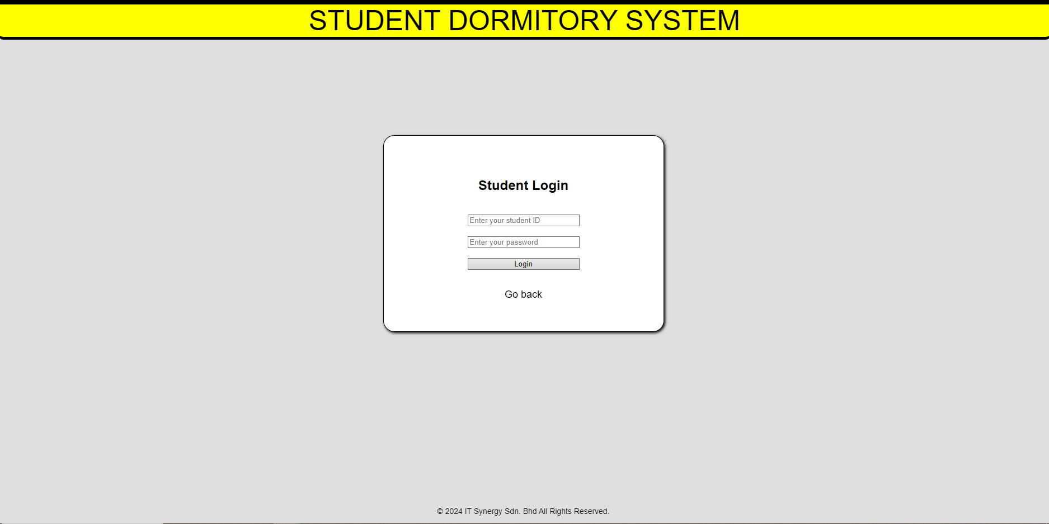

Login Page Warden

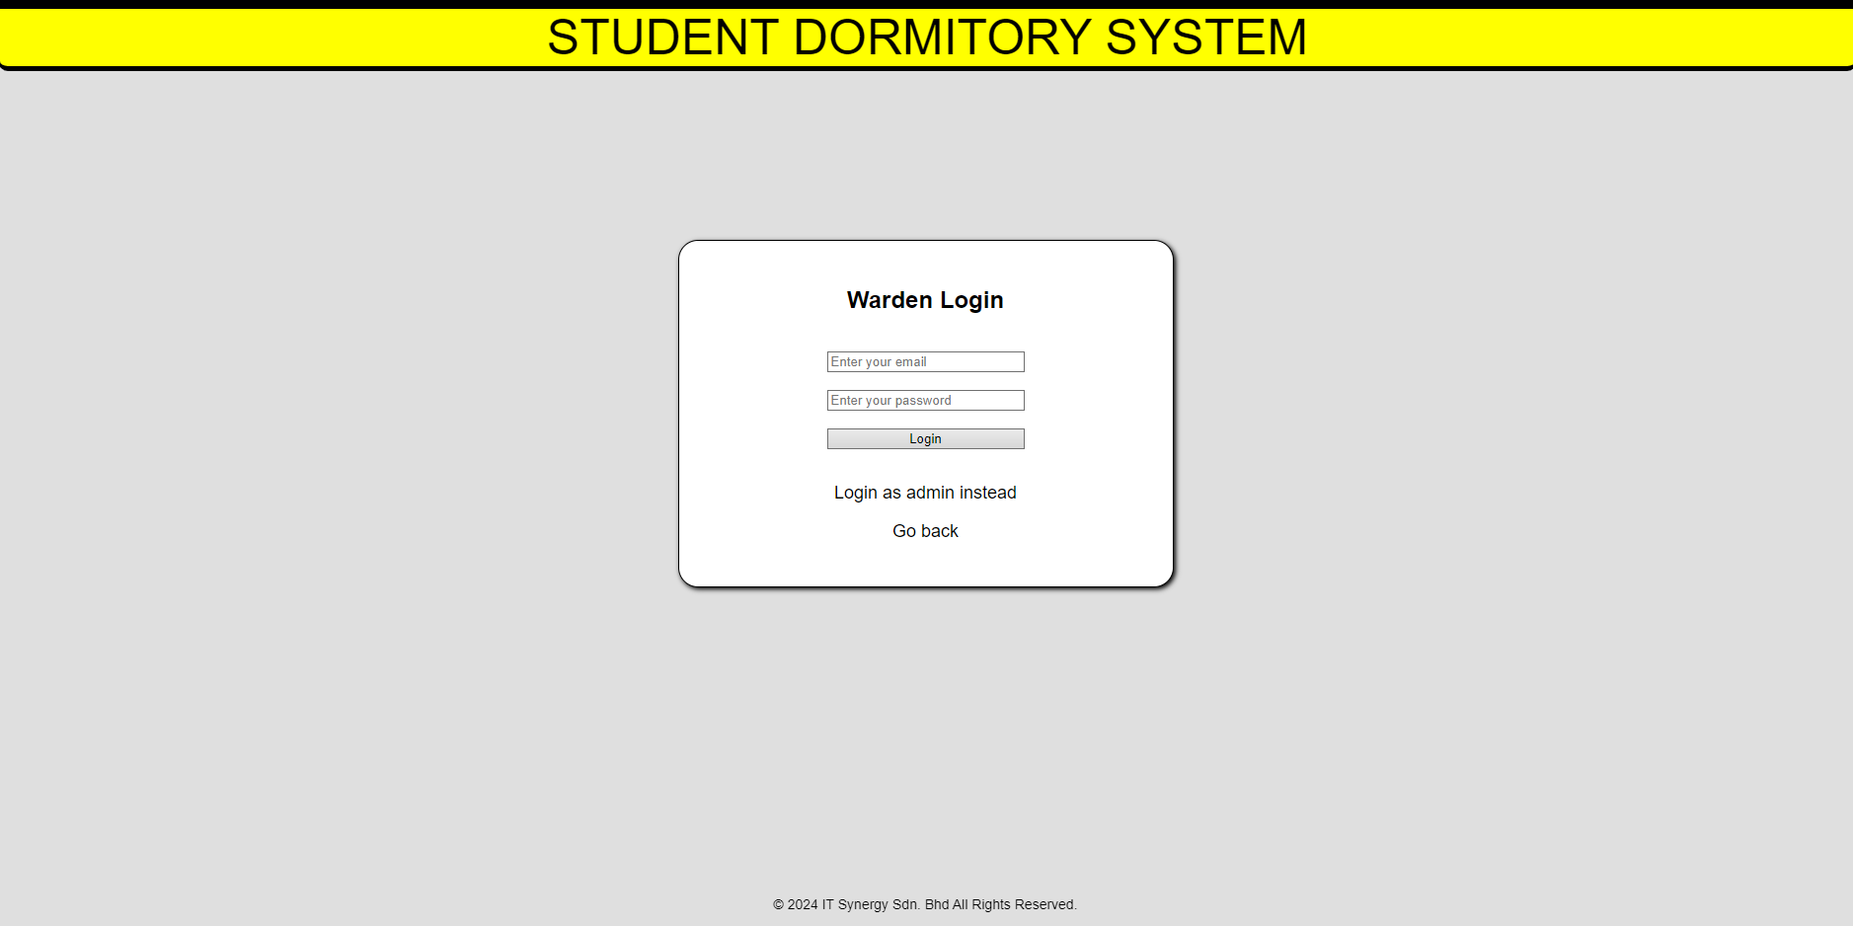

Login Page Admin

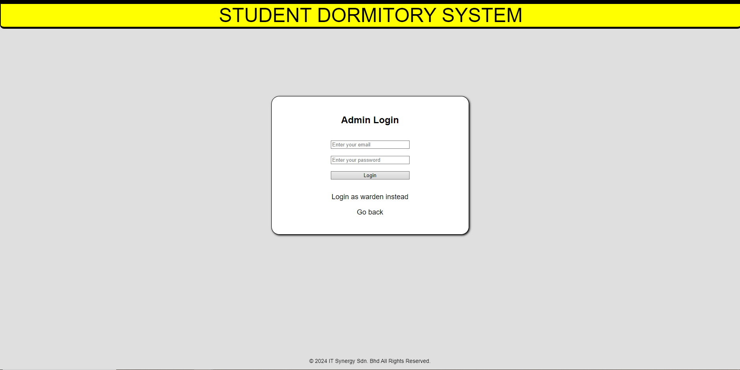

Student Main/Home Page

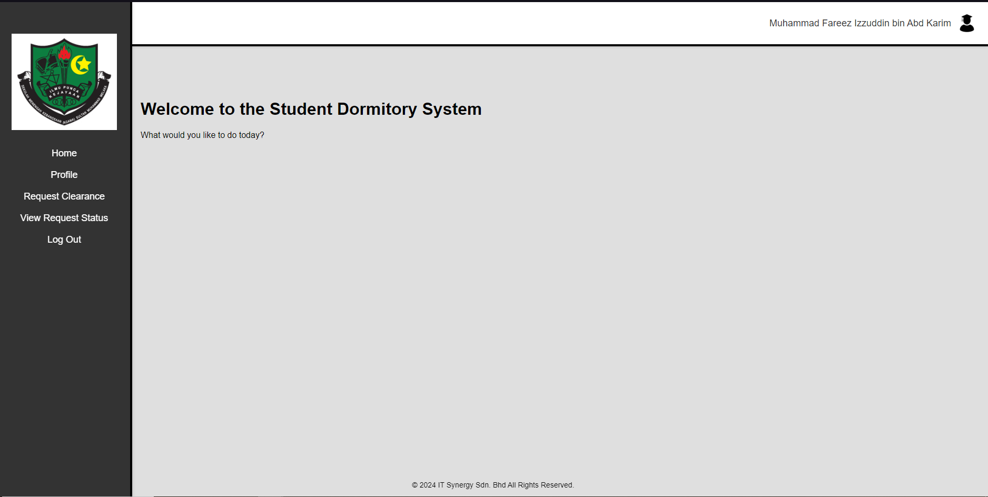

Student Profile

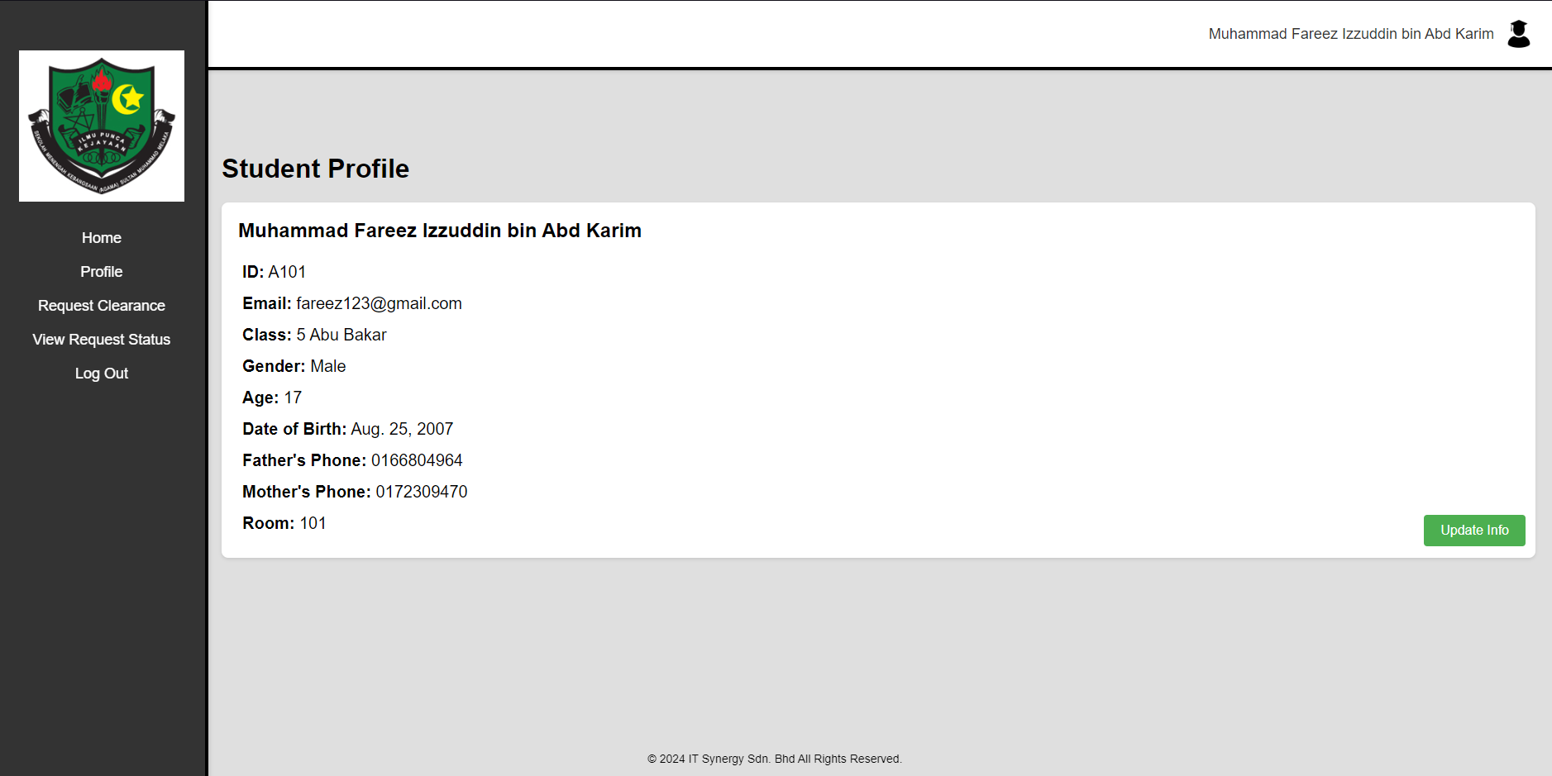

Student Profile Update Information Page

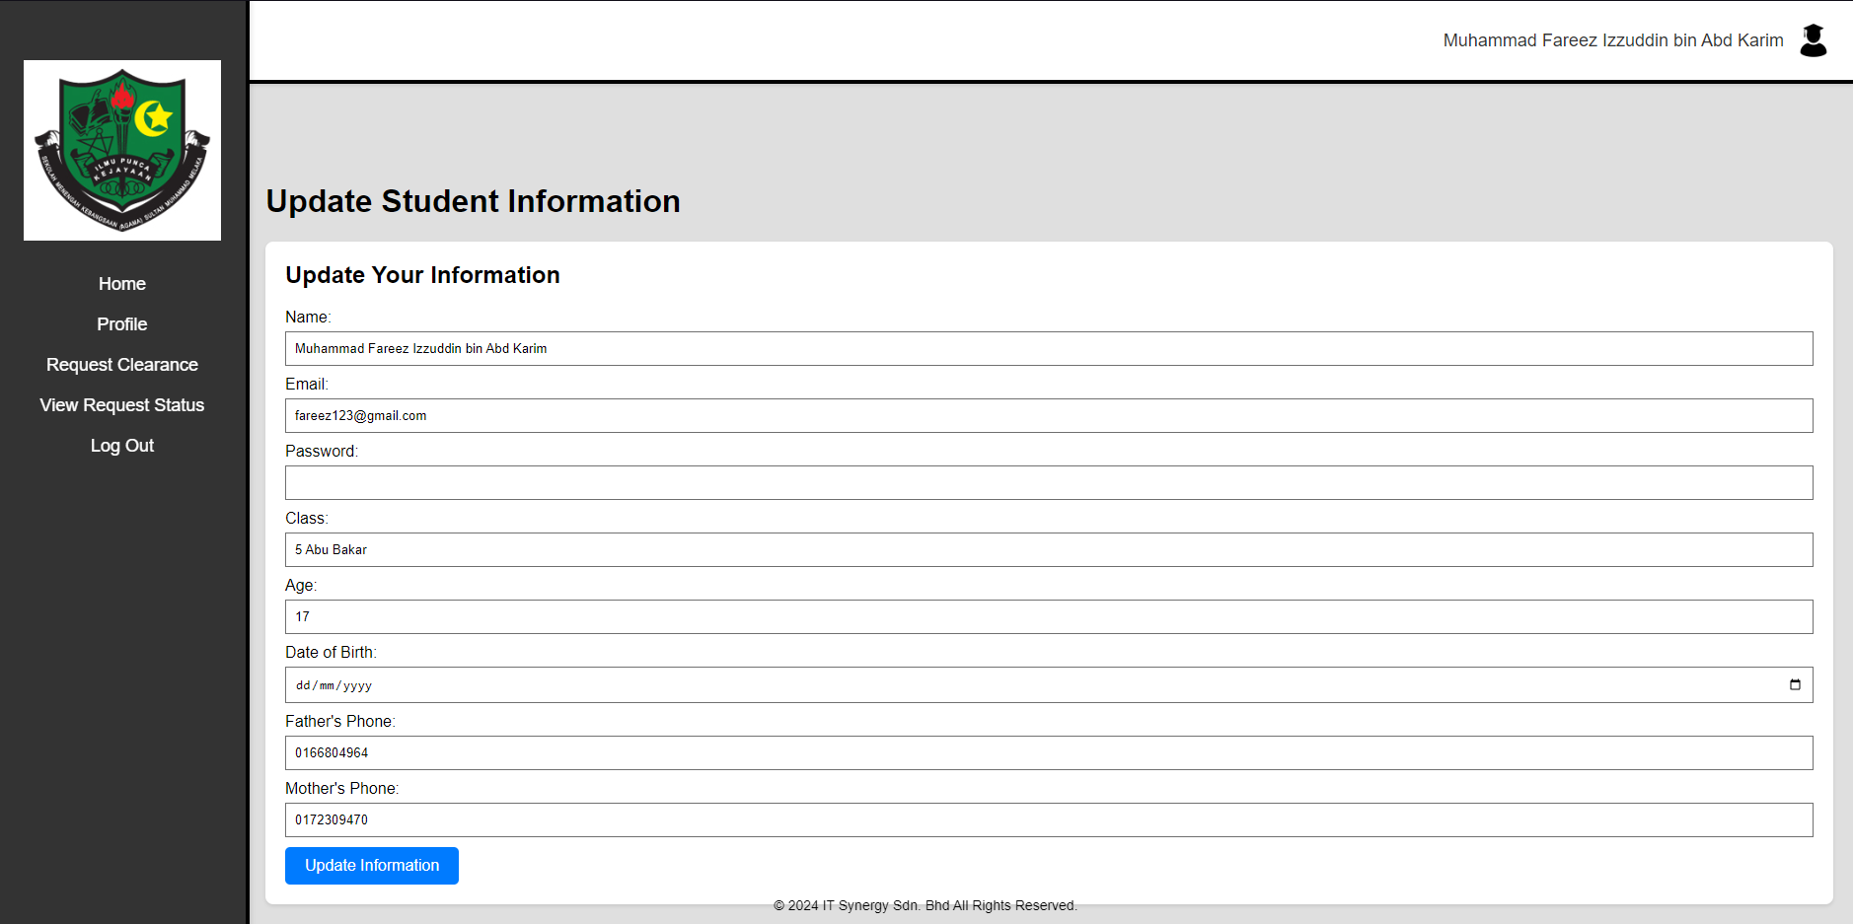

Student Request Clearance

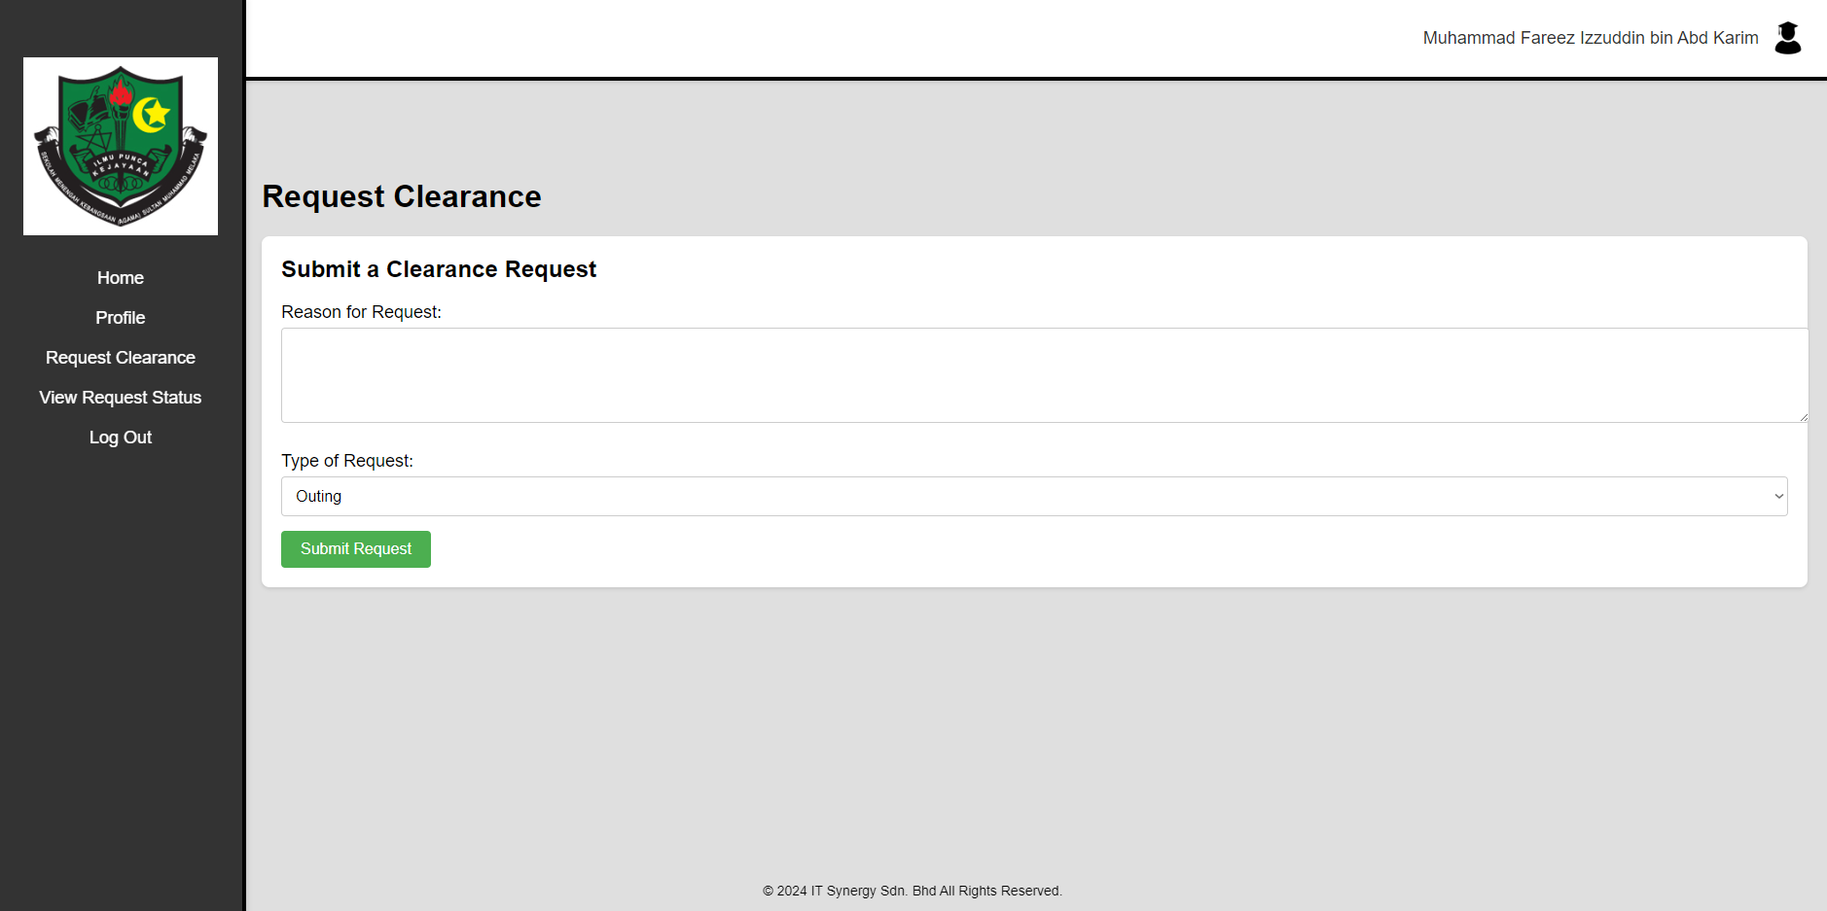

Student View Request Status

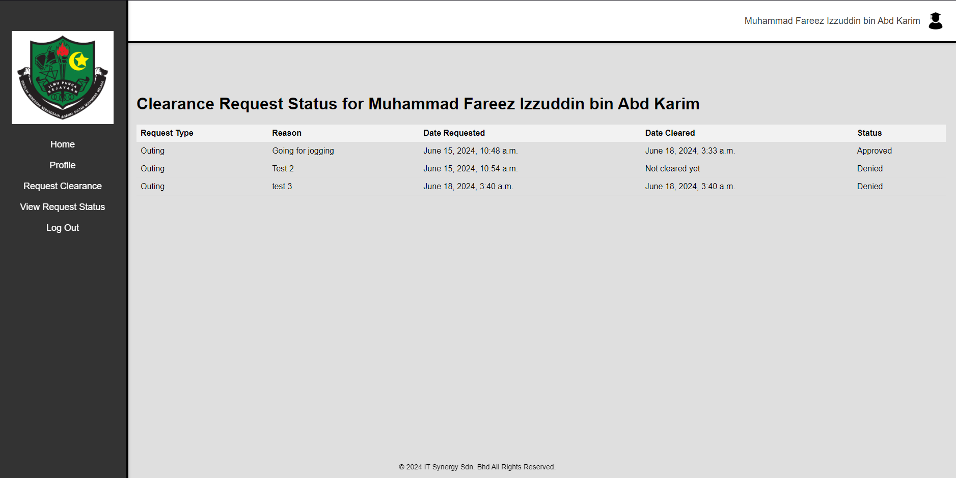

Warden Main/Home Page

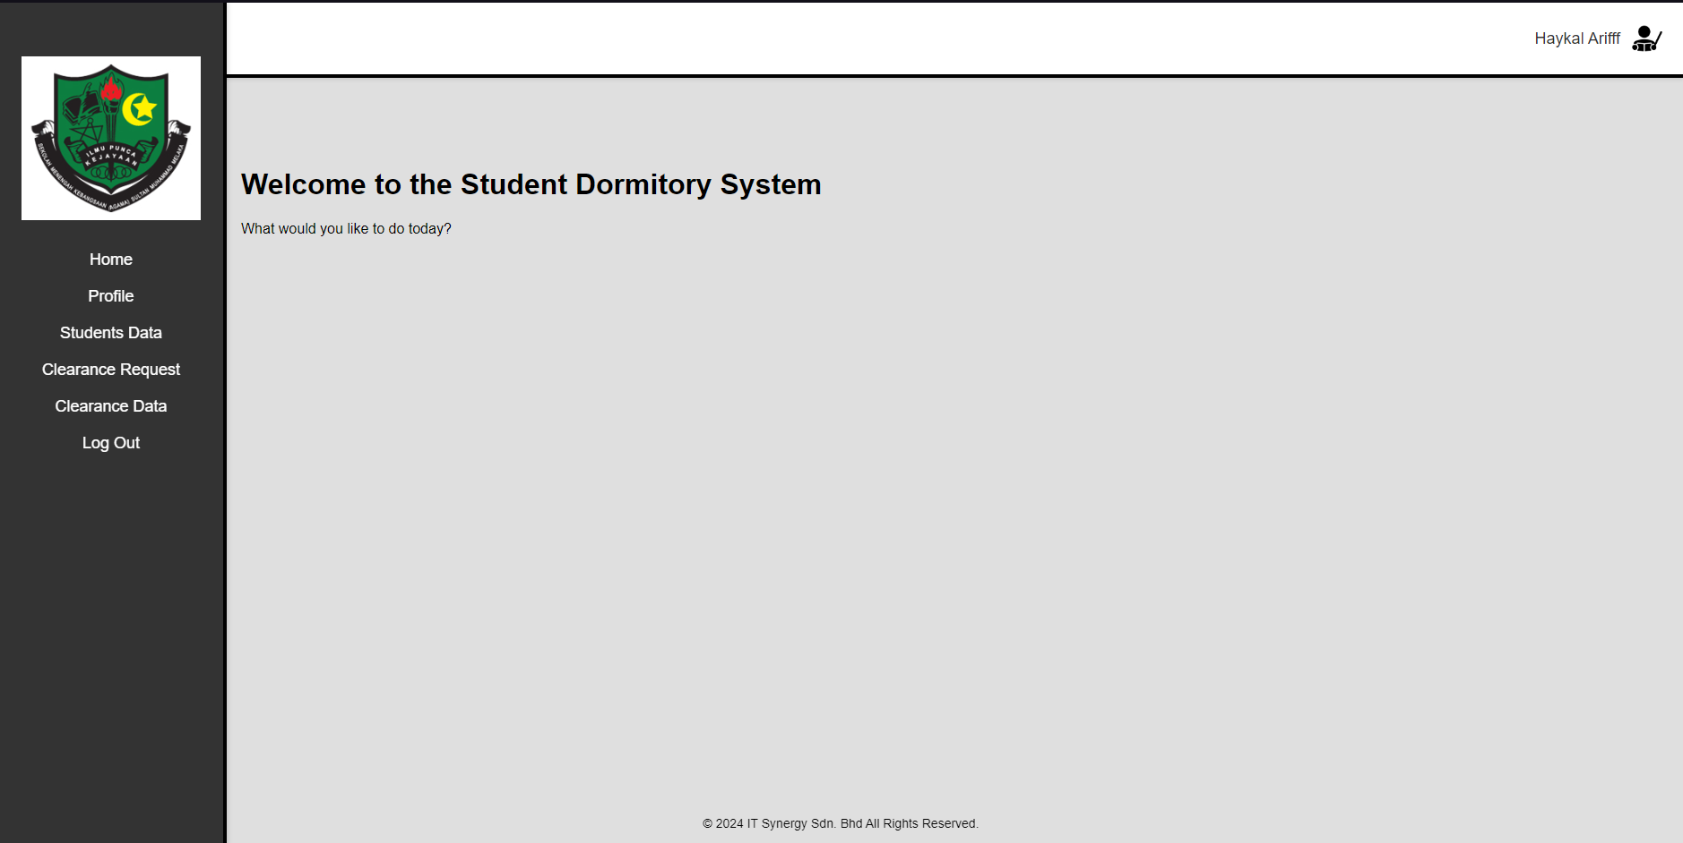

Warden Profile Page

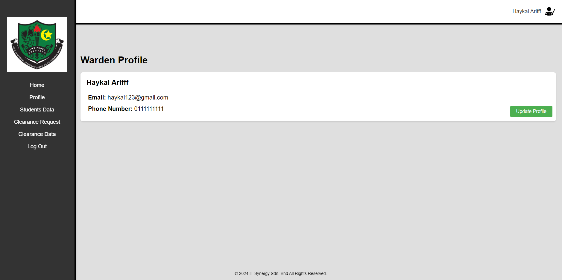

Warden Profile Update Information Page

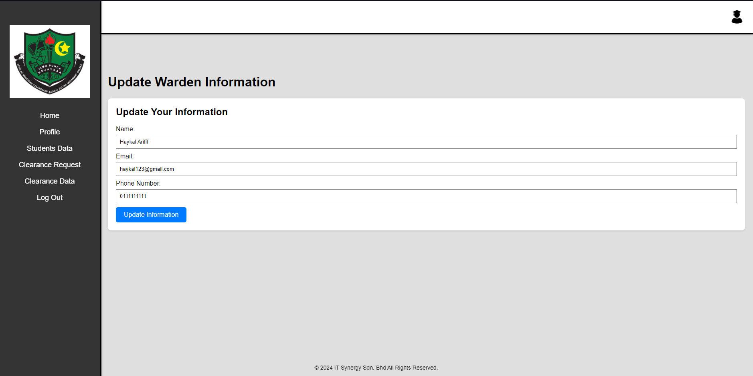

Warden Students Data Page

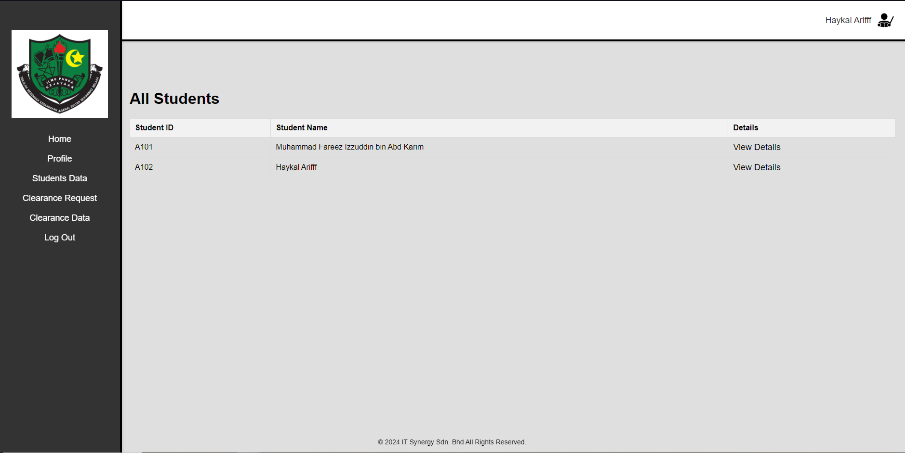

Warden Student Details Page

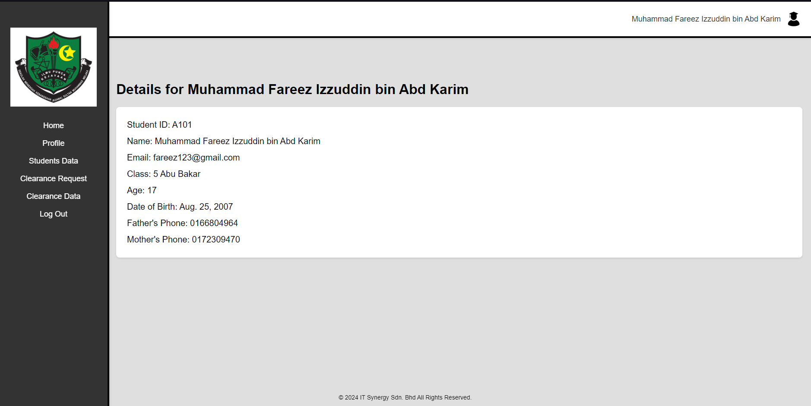

Warden Clearance Request Page

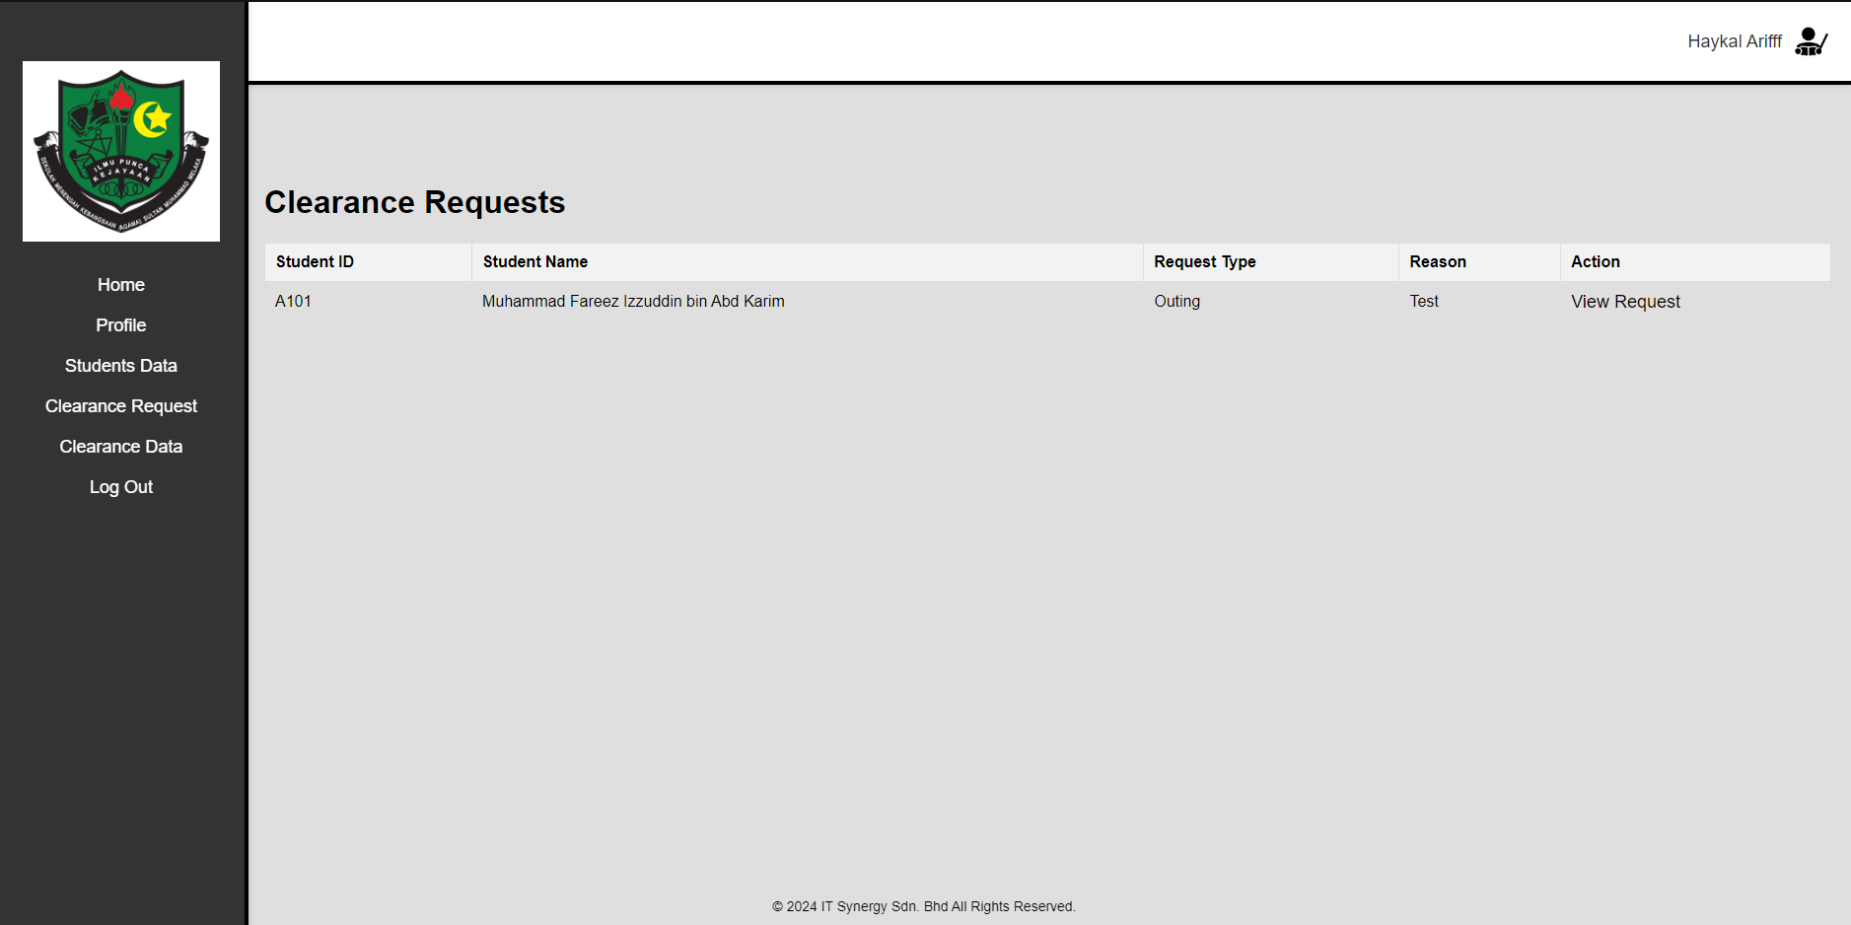

Warden Clearance Details Page

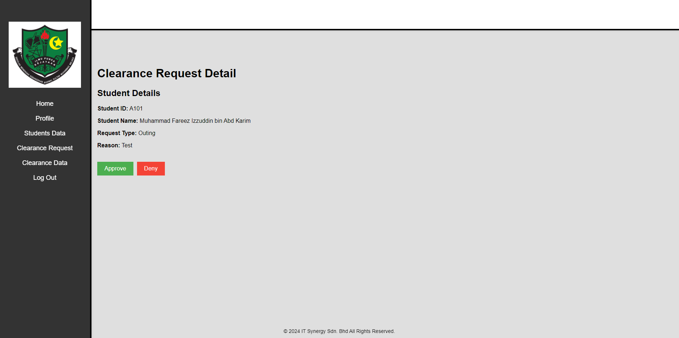

Warden Clearance Data Page

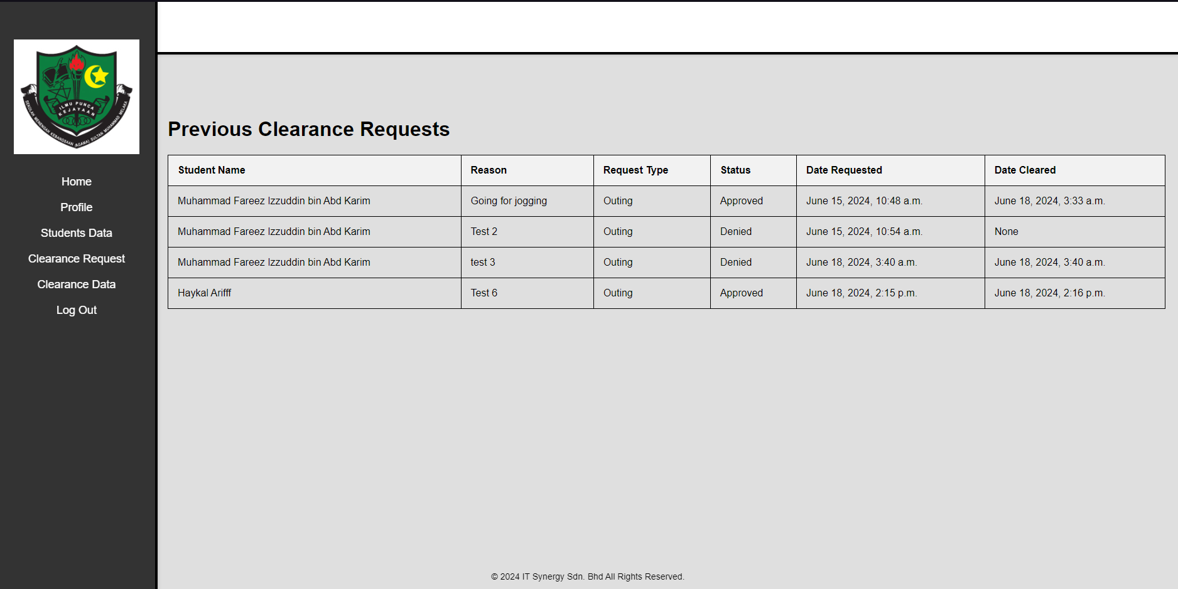

Admin Main/Home Page

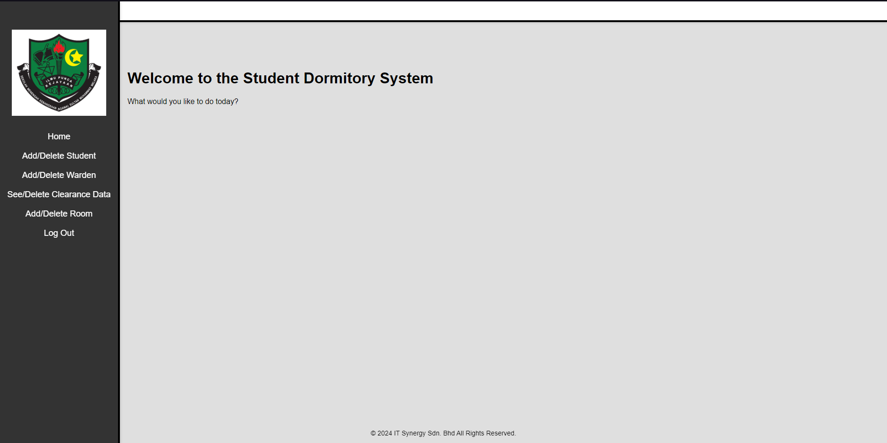

Admin Add/Delete Student Page

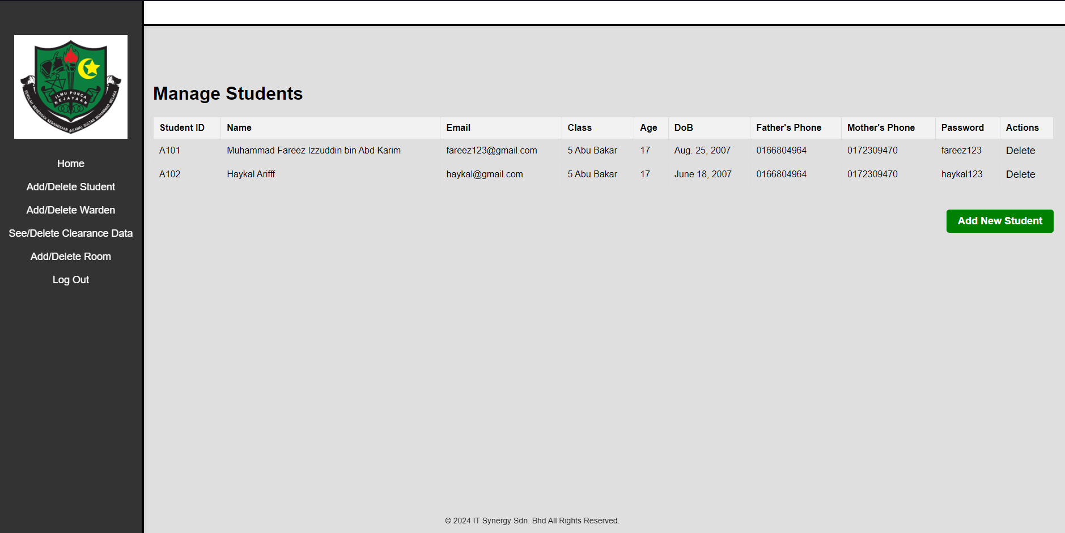

Admin Add New Student Page

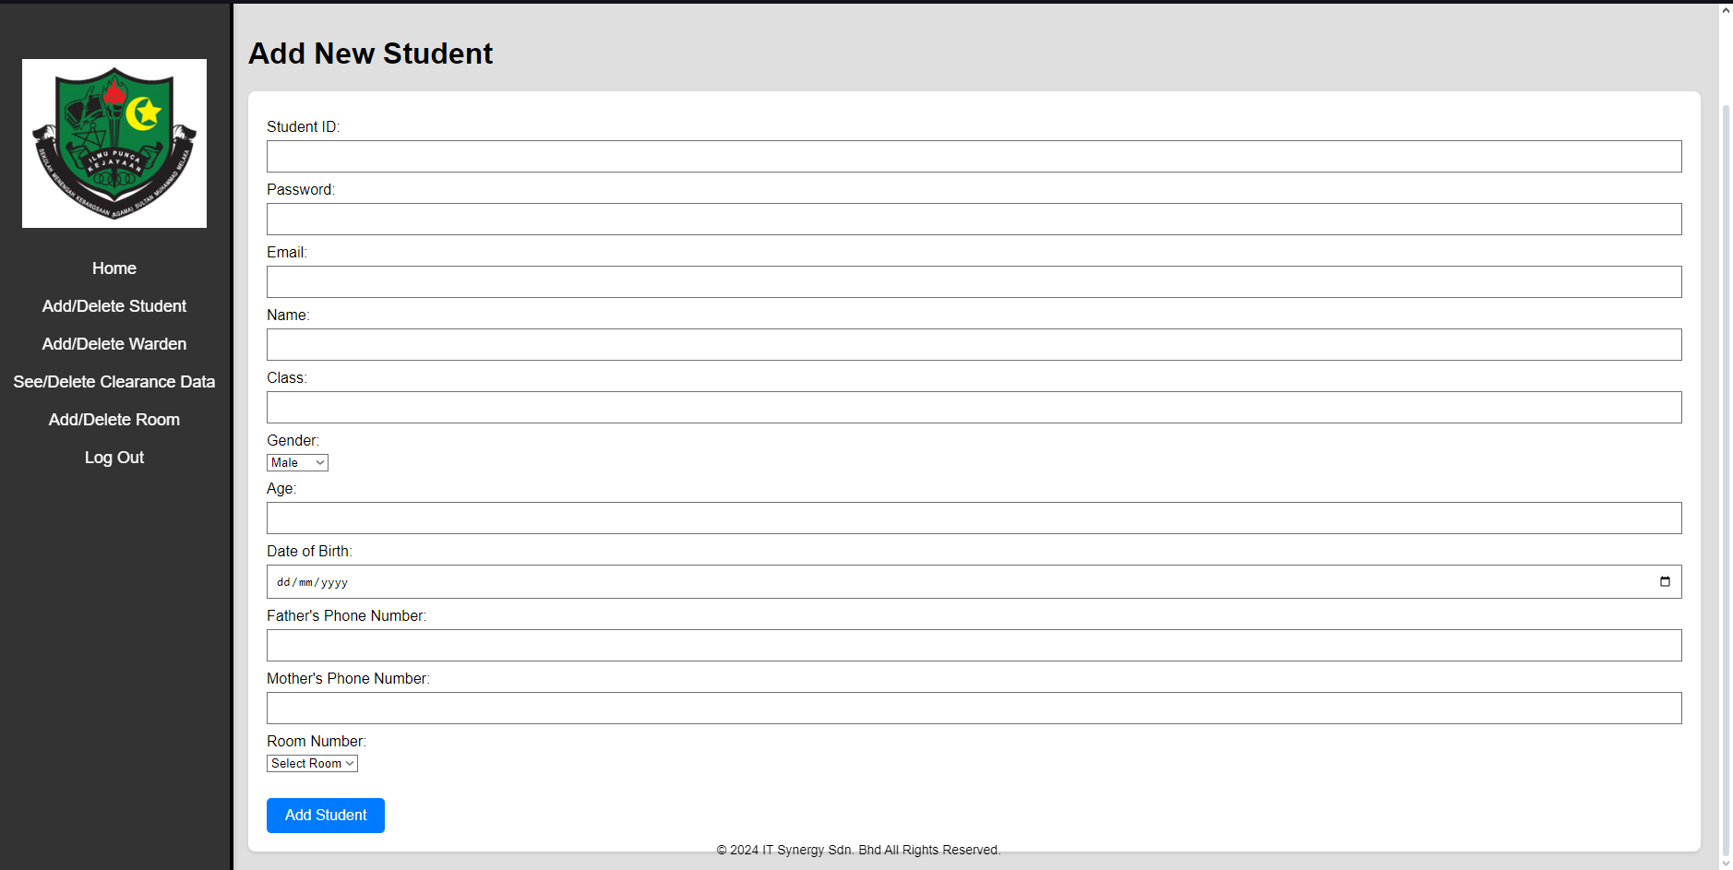

Admin Add/Delete Warden Page

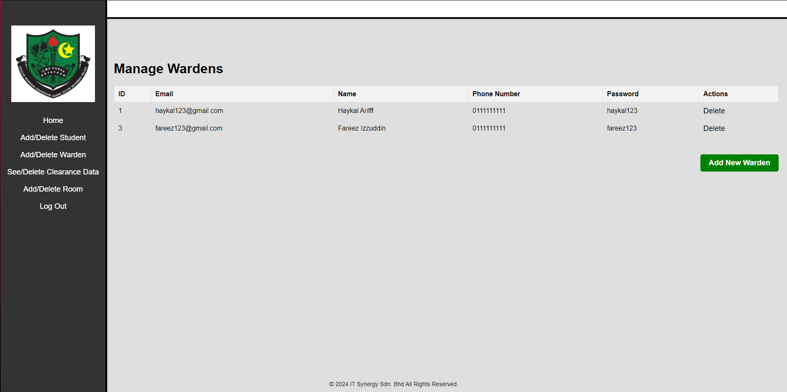

Admin Add New Warden Page

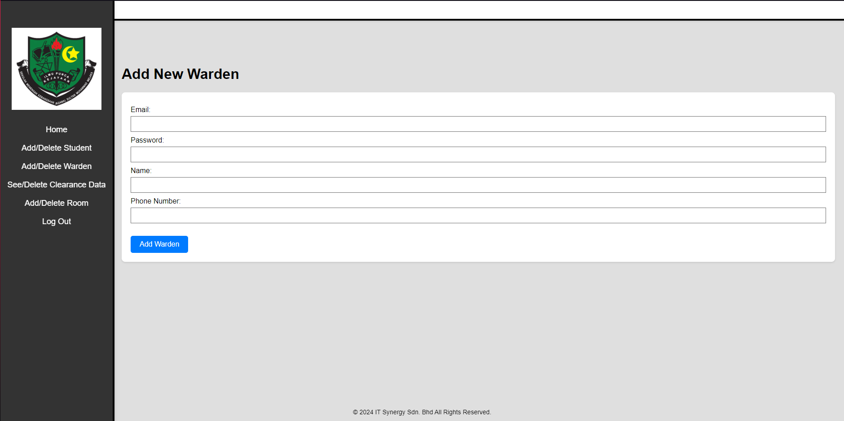

Admin See/Delete Clearance Data Page

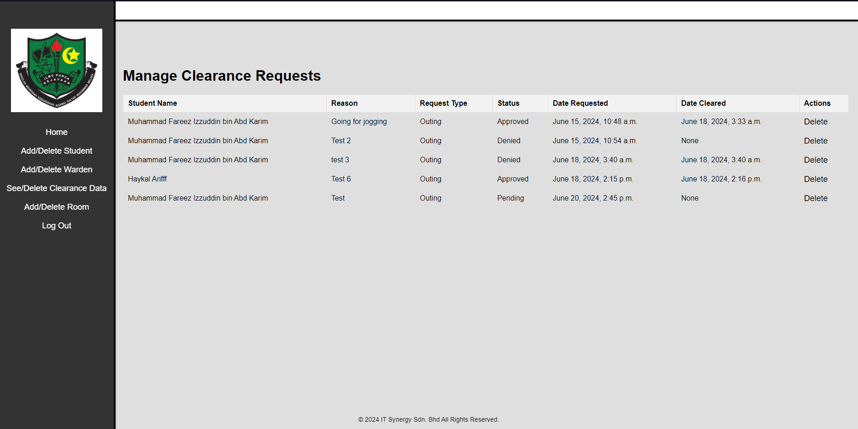

Admin Add/Delete Room Page

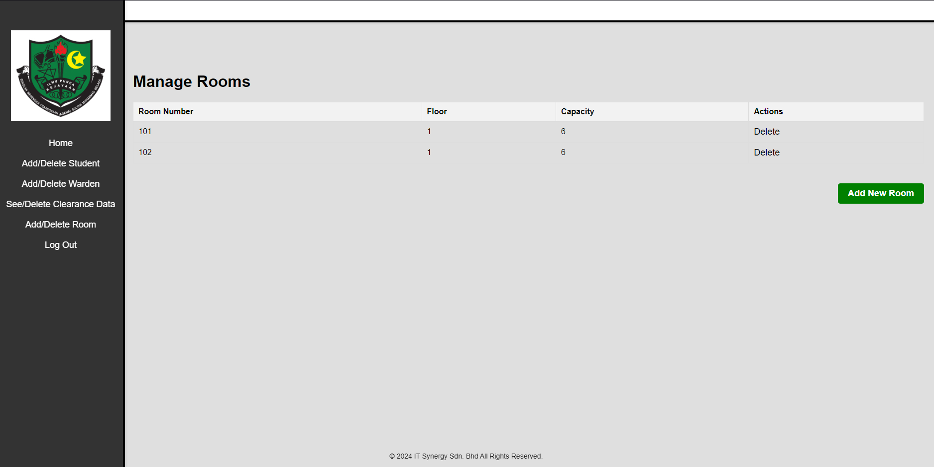

Admin Add New Room Page

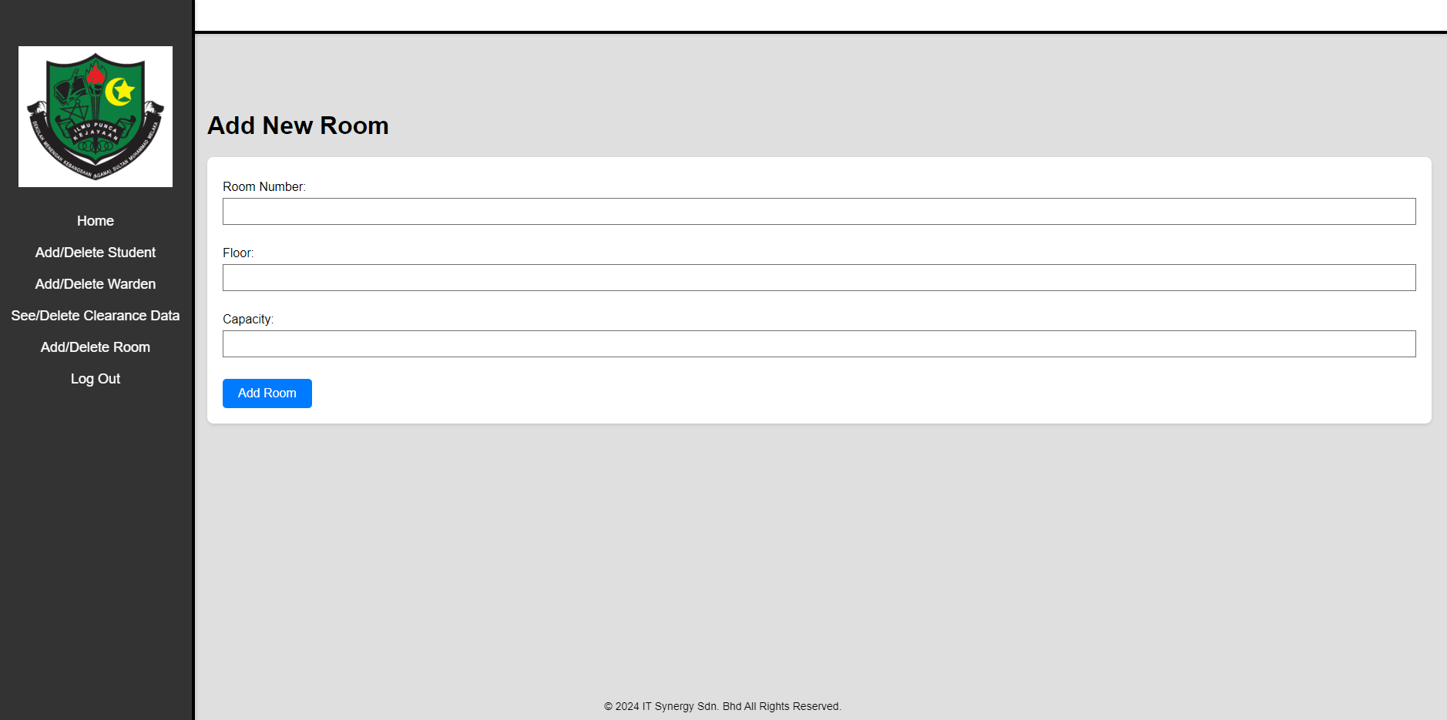

Test Case

Login Page

|  |  |  |  |  |  |
| --- | --- | --- | --- | --- | --- |
| Test Case ID | Test Case Description | Input Data | Expected Result | Actual Result | Pass/Fail |
| TC001 | Test Student “Login” button | Student: Student ID  Password | Login button function appropriately and successfully access to the account based on the user role | Login button successfully | Pass |
| TC002 | Test Warden “Login” button | Warden: Email Password | Login button function appropriately and successfully access to the account based on the user role | Login button successfully | Pass |
| TC003 | Test Admin “Login” button | Admin: Email  Password | Login button function appropriately and successfully access to the account based on the user role | Login button successfully | Pass |

Student Page

|  |  |  |  |  |  |
| --- | --- | --- | --- | --- | --- |
| Test Case ID | Test Case Description | Input Data | Expected Result | Actual Result | Pass/Fail |
| TC004 | Press the Home button to redirect back to home page | Pressing the Home button | Redirect back to Student home page | Redirect to Student home page successfully | Pass |
| TC005 | Press the Profile button to redirect to profile page | Pressing the Profile button | Redirect to Student Profile page | Redirect to Student Profile page successfully | Pass |
| TC006 | Press the Request Clearance button to redirect to request clearance page | Pressing the Request Clearance button | Redirect to Request Clearance page | Redirect to Request Clearance page successfully | Pass |
| TC007 | Press the Request Status button to redirect to request status page | Pressing the Request Status button | Redirect to Request Status page | Redirect to Request Status page successfully | Pass |

Student Edit Profile

|  |  |  |  |  |  |
| --- | --- | --- | --- | --- | --- |
| Test Case ID | Test Case Description | Input Data | Expected Result | Actual Result | Pass/Fail |
| TC008 | Verify that student can change their profile information and save it | Student inputting new information of their profile | Information change function works | Profile information change and save successfully | Pass |

Student Clearance Request

|  |  |  |  |  |  |
| --- | --- | --- | --- | --- | --- |
| Test Case ID | Test Case Description | Input Data | Expected Result | Actual Result | Pass/Fail |
| TC009 | Verify student can apply for clearance without fill in reason | Student pressing apply for clearance | Request Clearance save successfully | Request Clearance failed to save the request | Fail |

Warden Page

|  |  |  |  |  |  |
| --- | --- | --- | --- | --- | --- |
| Test Case ID | Test Case Description | Input Data | Expected Result | Actual Result | Pass/Fail |
| TC010 | Press the Home button to redirect back to home page | Pressing the Home button | Redirect back to Warden home page | Redirect to Warden home page successfully | Pass |
| TC011 | Press the Profile button to redirect to profile page | Pressing the Profile button | Redirect to Warden Profile page | Redirect to Warden Profile page successfully | Pass |
| TC012 | Press the Students Data button to redirect to students data page | Pressing the Students Data button | Redirect to Students Data page | Redirect to Students Data page successfully | Pass |
| TC013 | Press the Clearance Request button to redirect to clearance request page | Pressing the Request Clearance button | Redirect to Request Clearance page | Redirect to Request Clearance page successfully | Pass |
| TC014 | Press the Clearance Data button to redirect to clearance data page | Pressing the Clearance Data button | Redirect to Clearance Data page | Redirect to Clearance Data page successfully | Pass |

Warden Clearance Request

|  |  |  |  |  |  |
| --- | --- | --- | --- | --- | --- |
| Test Case ID | Test Case Description | Input Data | Expected Result | Actual Result | Pass/Fail |
| TC015 | Warden pressing approve or deny to student’s clearance request | Pressing approve/deny button | The clearance request database change according to the choice | The clearance request database change according to the choice successfully | Pass |

Admin Page

|  |  |  |  |  |  |
| --- | --- | --- | --- | --- | --- |
| Test Case ID | Test Case Description | Input Data | Expected Result | Actual Result | Pass/Fail |
| TC016 | Press the Home button to redirect back to home page | Pressing the Home button | Redirect back to Admin home page | Redirect to Admin home page successfully | Pass |
| TC017 | Press the Add/Delete Student button to redirect to add/delete student page | Pressing the Add/Delete Student button | Redirect to Add/Delete Student page | Redirect to Add/Delete Student page successfully | Pass |
| TC018 | Press the Add/Delete Warden button to redirect to add/delete warden page | Pressing the Add/Delete Warden button | Redirect to Add/Delete Warden page | Redirect to Add/Delete Warden page successfully | Pass |
| TC019 | Press the See/Delete Clearance Data button to redirect to see/delete clearance data page | Pressing the See/Delete Clearance Data button | Redirect to See/Delete Clearance Data page | Redirect to See/Delete Clearance Data page successfully | Pass |
| TC020 | Press the Add/Delete room button to redirect to add/delete room page | Pressing the Add/Delete room button | Redirect to Add/Delete room page | Redirect to Add/Delete room page successfully | Pass |

Add/Delete Data

|  |  |  |  |  |  |
| --- | --- | --- | --- | --- | --- |
| Test Case ID | Test Case Description | Input Data | Expected Result | Actual/Result | Pass/Fail |
| TC021 | Admin fill in a form to add a new student | Admin: Student Information | New student saves in the database | New student saves in the database successfully | Pass |
| TC022 | Admin delete a student by pressing “Delete” button | Admin press the “Delete” button | Student deleted from the database | Student deleted from the database successfully | Pass |